# Homework Assignment: Cliffs of Winsanity Linux Challenge

Or, Troublesome Process Termination Challenge.

Access this challenge through the Winconceivable: Cliffs of Winsanity. This challenge teaches you about aliases in Linux. In both Linux and Windows, an alias can be used like a shortcut on a GUI Desktop, but from the command line. The alias can save typing, or cause trouble if it is used maliciously.



The terminal is sitting on top of the small building.

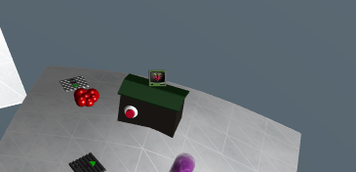

Sparkle Redberry needs you to kill the santaslittlehelperd process. You can see the running processes and their process IDs (pid) with ps aux, and you normally use kill <pid> to stop them. Not in this case. Use ps aux | grep santa to find the pid of the troublesome process, and then try to kill it with kill <pid>. Check ps aux again to see if the process is gone. Most likely, it will still be running. Rats.

# Some Hints

Sparkle has been doing research on “alias”, according to her tweets. 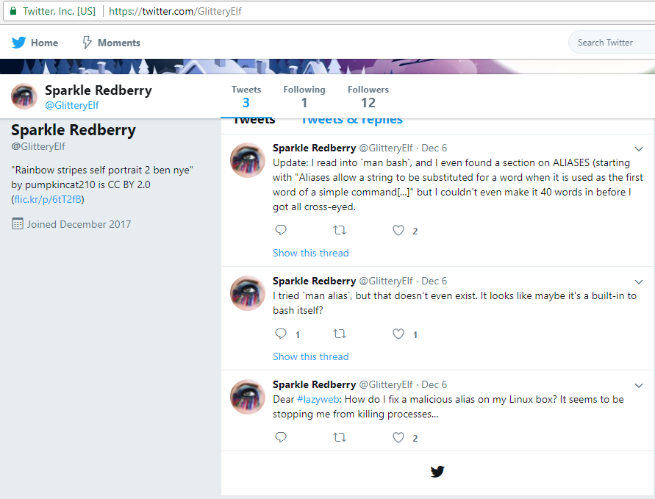

So, something to do with “alias” is causing commands not to run.

# Questions

1. Submit a screenshot of your solution.
2. Submit a brief description of how it works.